**LIBRARY DATABASE**

**CREATION AND INSERTION OF VALUES:**

**Table structure for table `book`**

CREATE TABLE `books` (

`isbn` char(13) NOT NULL,

`title` varchar(80) NOT NULL,

`author` varchar(80) NOT NULL,

`category` varchar(80) NOT NULL,

`price` int(4) UNSIGNED NOT NULL,

`copies` int(10) UNSIGNED NOT NULL

);

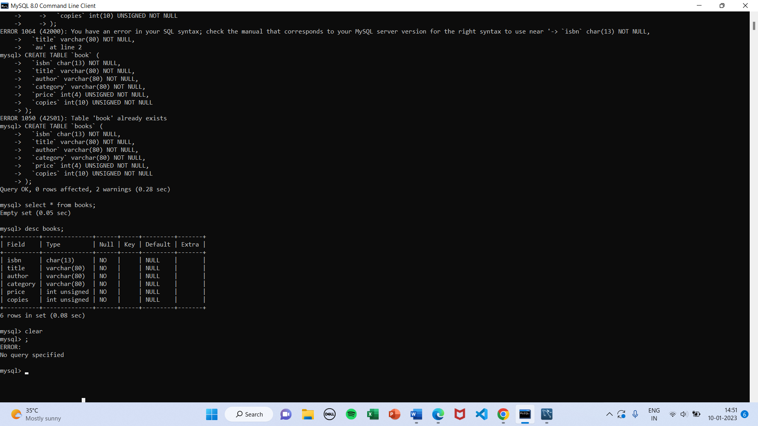

**Inserting data for table `book`**

INSERT INTO `books` (`isbn`, `title`, `author`, `category`, `price`, `copies`) VALUES

('0000545010225', 'Harry Potter and the Deathly Hallows', 'J. K. Rowling', 'Fiction', 550, 30),

('0000553103547', 'A Game of Thrones', 'George R. R. Martin', 'Fiction', 500, 10),

('0000553106635', 'A Storm of Swords', 'George R. R. Martin', 'Fiction', 550, 15),

('0000553108034', 'A Clash of Kings', 'George R. R. Martin', 'Fiction', 500, 10),

('0000553801503', 'A Feast for Crows', 'George R. R. Martin', 'Fiction', 600, 20),

('0000747532699', 'Harry Potter and the Philosopher''s Stone', 'J. K. Rowling', 'Fiction', 300, 12),

('0000747538492', 'Harry Potter and the Chamber of Secrets', 'J. K. Rowling', 'Fiction', 300, 10),

('0000747542155', 'Harry Potter and the Prisoner of Azkaban', 'J. K. Rowling', 'Fiction', 350, 16),

('0000747546240', 'Harry Potter and the Goblet of Fire', 'J. K. Rowling', 'Fiction', 400, 15),

('0000747551006', 'Harry Potter and the Order of the Phoenix', 'J. K. Rowling', 'Fiction', 400, 20),

('0000747581088', 'Harry Potter and the Half-Blood Prince', 'J. K. Rowling', 'Fiction', 500, 25),

('9780066620992', 'Good to Great', 'Jim Collins', 'Non-fiction', 300, 10),

('9780241257555', 'The Pigeon Tunnel', 'John le CarrÃƒÂ©', 'Non-fiction', 200, 25),

('9780439023511', 'Mockingjay', 'Suzanne Collins', 'Fiction', 500, 20),

('9780439023528', 'The Hunger Games', 'Suzanne Collins', 'Fiction', 400, 10),

('9780545227247', 'Catching Fire', 'Suzanne Collins', 'Fiction', 400, 14),

('9780553801477', 'A Dance with Dragons', 'George R. R. Martin', 'Fiction', 600, 30),

('9780967752808', 'Sandbox Wisdom', 'Tom Asacker', 'Non-fiction', 250, 5),

('9781501141515', 'Born to Run', 'Bruce Springsteen', 'Non-fiction', 250, 20),

('9788183331630', 'Let Us C', 'Yashavant Kanetkar', 'Education', 200, 22),

('9789350776667', 'Computer Graphics and Virtual Reality', 'Sanjesh S. Pawale', 'Education', 100, 30),

('9789350776773', 'Microcontroller and Embedded Systems', 'Harish G. Narula', 'Education', 80, 15),

('9789350777077', 'Advanced Database Management Systems', 'Mahesh Mali', 'Education', 60, 29),

('9789350777121', 'Operating Systems', 'Rajesh Kadu', 'Education', 50, 24),

('9789351194545', 'Open Source Technologies', 'Dayanand Ambawade', 'Education', 100, 20),

('9789381626719', 'Stay Hungry Stay Foolish', 'Rashmi Bansal', 'Non-fiction', 100, 5);

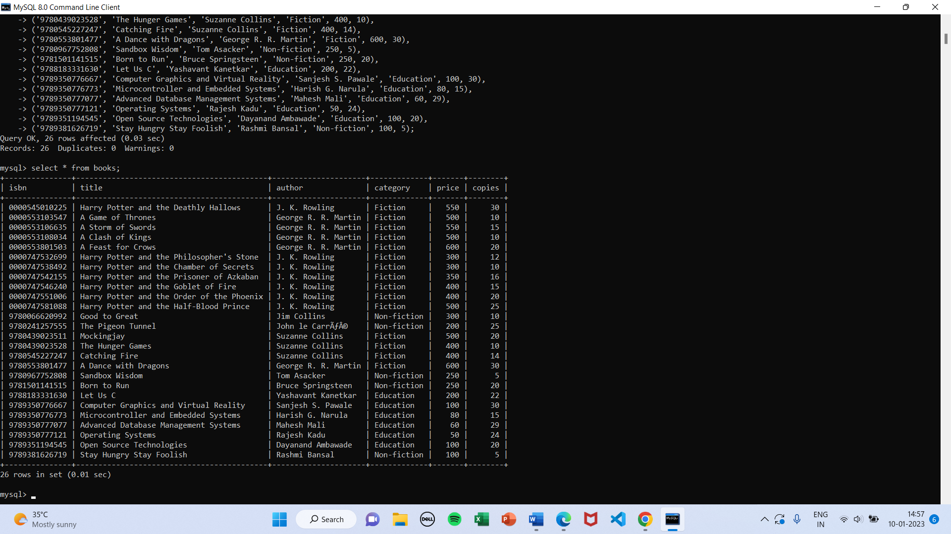

**Table structure for table `book_issue_log`**

CREATE TABLE `book_issue_log` (

`issue_id` int(11) NOT NULL,

`member` varchar(20) NOT NULL,

`book_isbn` varchar(13) NOT NULL,

`due_date` date NOT NULL,

`last_reminded` date DEFAULT NULL);

**Inserting data for table `book_issue_log`**

INSERT INTO `book_issue_log` (`issue_id`, `member`, `book_isbn`, `due_date`, `last_reminded`) VALUES

(1, 'seph32', '9789350777077', '2016-10-17', NULL),

(2, 'seph32', '9780545227247', '2016-10-17', NULL);

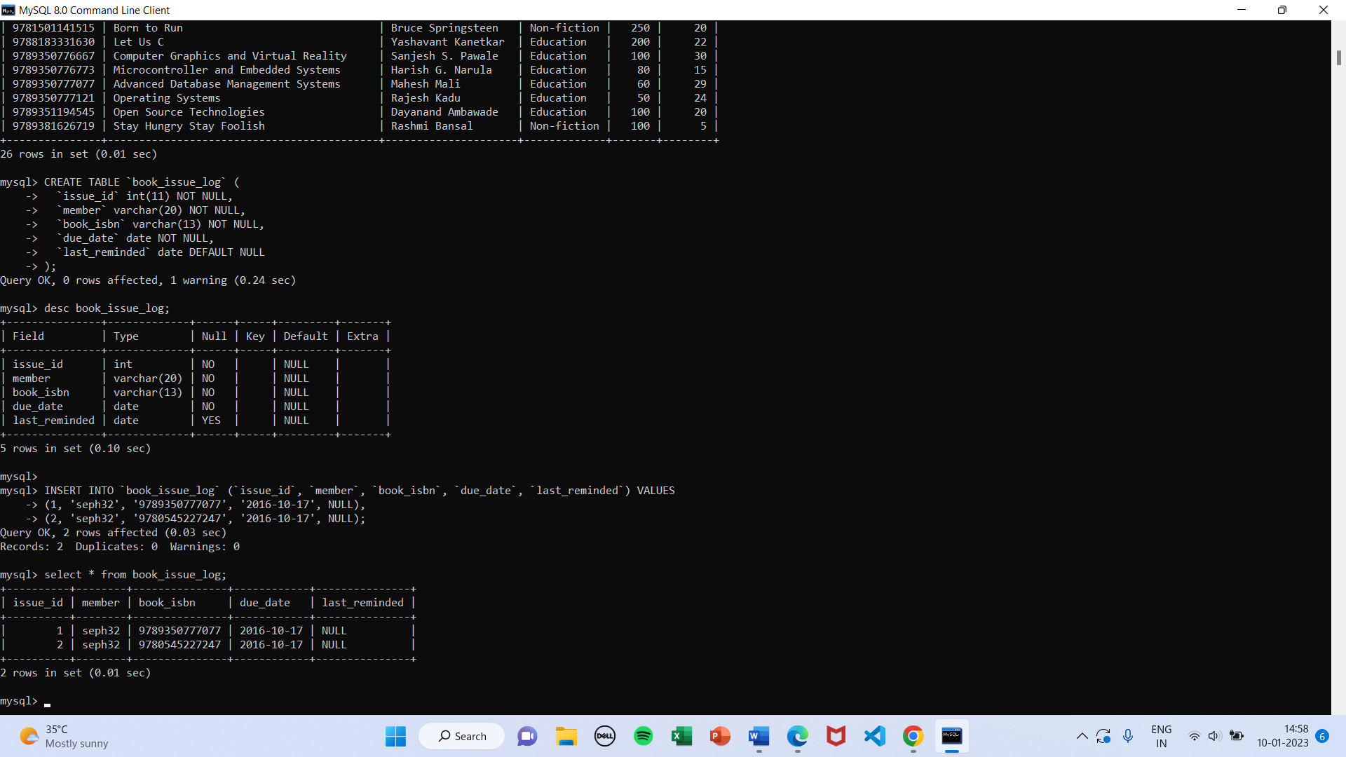

**Table structure for table `librarian`**

CREATE TABLE `librarian` (

`id` int(11) NOT NULL,

`username` varchar(20) NOT NULL,

`password` char(40) NOT NULL

) ENGINE=InnoDB DEFAULT CHARSET=latin1;

**Inserting data for table `librarian`**

INSERT INTO `librarian` (`id`, `username`, `password`) VALUES

(1, 'genesis', '93c768d0152f72bc8d5e782c0b585acc35fb0442');

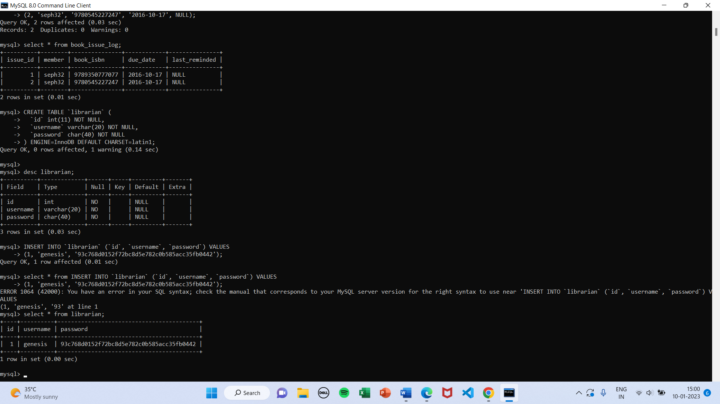



**Table structure for table `member`**

CREATE TABLE `member` (

`id` int(11) NOT NULL,

`username` varchar(20) NOT NULL,

`password` char(40) NOT NULL,

`name` varchar(80) NOT NULL,

`email` varchar(80) NOT NULL,

`balance` int(4) NOT NULL

) ENGINE=InnoDB DEFAULT CHARSET=latin1;

**Inserting data for table `member`**

INSERT INTO `member` (`id`, `username`, `password`, `name`, `email`, `balance`) VALUES

(1, 'cloud9', 'c67adbca4bd9f7e583f05f4c7edbcb733c7c9233', 'Cloud Strife', 'cloud@shinra.com', 1000),

(2, 'seph32', '75bf2b008d91258f56fc0d3a938ca64b8a631533', 'Sephiroth', 'seph@shinra.com', 540),

(3, 'zack_ff7', '52d849001964af394040dc48b673f748e55e1af7', 'Zack Fair', 'zack@shinra.com', 1000);

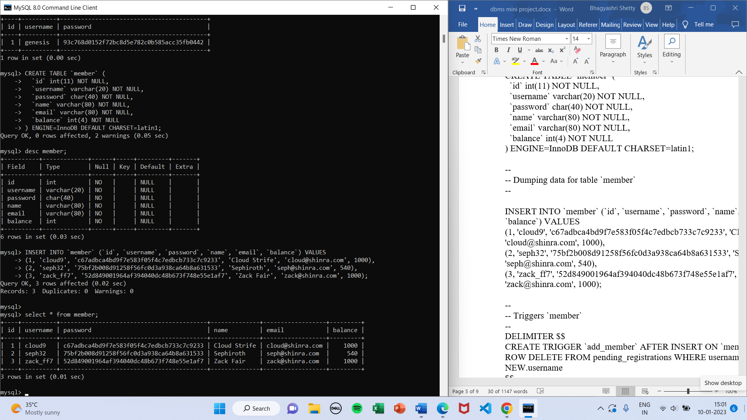

**Table structure for table `pending_book_requests`**

CREATE TABLE `pending_book_requests` (

`request_id` int(11) NOT NULL,

`member` varchar(20) NOT NULL,

`book_isbn` varchar(13) NOT NULL,

`time` timestamp NOT NULL DEFAULT CURRENT_TIMESTAMP

) ENGINE=InnoDB DEFAULT CHARSET=latin1;

**Inserting data for table `pending_book_requests`**

INSERT INTO `pending_book_requests` (`request_id`, `member`, `book_isbn`, `time`) VALUES

(1, 'zack_ff7', '9780553801477', '2016-10-10 12:53:27'),

(2, 'cloud9', '0000545010225', '2016-10-10 12:53:59'),

(5, 'seph32', '0000553103547', '2016-10-10 12:59:45');

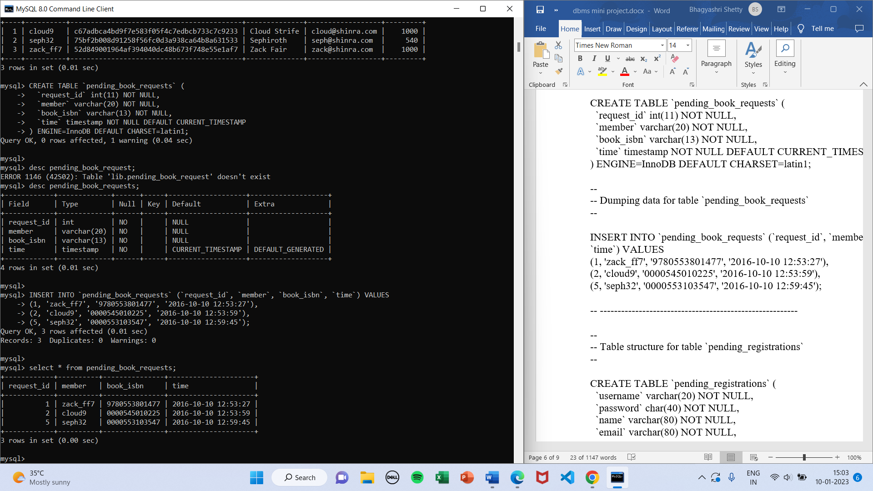

**Table structure for table `pending_registrations`**

CREATE TABLE `pending_registrations` (

`username` varchar(20) NOT NULL,

`password` char(40) NOT NULL,

`name` varchar(80) NOT NULL,

`email` varchar(80) NOT NULL,

`balance` int(4) NOT NULL,

`time` timestamp NOT NULL DEFAULT CURRENT_TIMESTAMP

) ENGINE=InnoDB DEFAULT CHARSET=latin1;

**Inserting data for table `pending_registrations`**

INSERT INTO `pending_registrations` (`username`, `password`, `name`, `email`, `balance`, `time`) VALUES

('test', 'a94a8fe5ccb19ba61c4c0873d391e987982fbbd3', 'Test', 'test@test.com', 500, '2016-10-10 13:01:13'),

('test2', '109f4b3c50d7b0df729d299bc6f8e9ef9066971f', 'Test 2', 'test2@test2.com', 800, '2016-10-10 13:03:41');

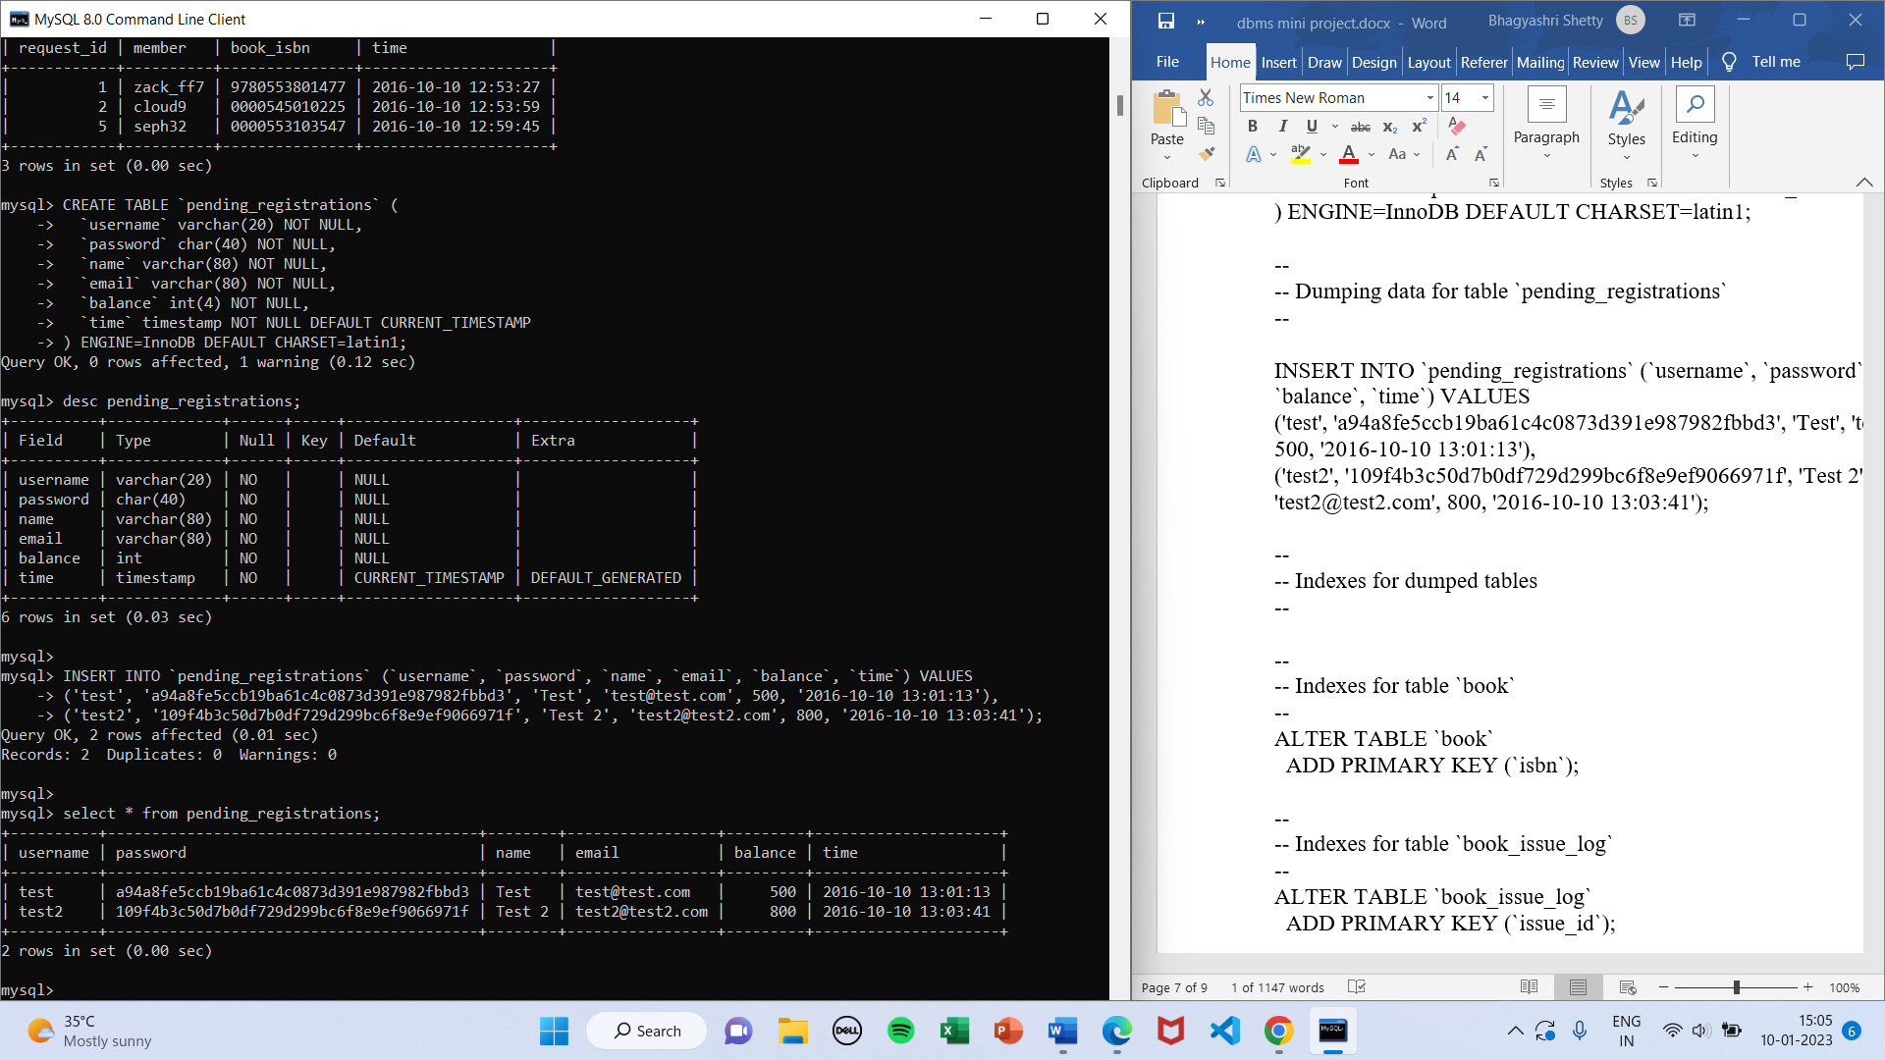

**ALTER COMMAND(insertion of primary key)**

**Indexes for table `book`**

ALTER TABLE `books`

ADD PRIMARY KEY (`isbn`);

**Indexes for table `book_issue_log`**

ALTER TABLE `book_issue_log`

ADD PRIMARY KEY (`issue_id`);

**Indexes for table `librarian`**

ALTER TABLE `librarian`

ADD PRIMARY KEY (`id`),

ADD UNIQUE KEY `username` (`username`);

**Indexes for table `member`**

ALTER TABLE `member`

ADD PRIMARY KEY (`id`),

ADD UNIQUE KEY `username` (`username`),

ADD UNIQUE KEY `email` (`email`);

**Indexes for table `pending_book_requests`**

ALTER TABLE `pending_book_requests`

ADD PRIMARY KEY (`request_id`);

**Indexes for table `pending_registrations`**

ALTER TABLE `pending_registrations`

ADD PRIMARY KEY (`username`),

ADD UNIQUE KEY `email` (`email`);

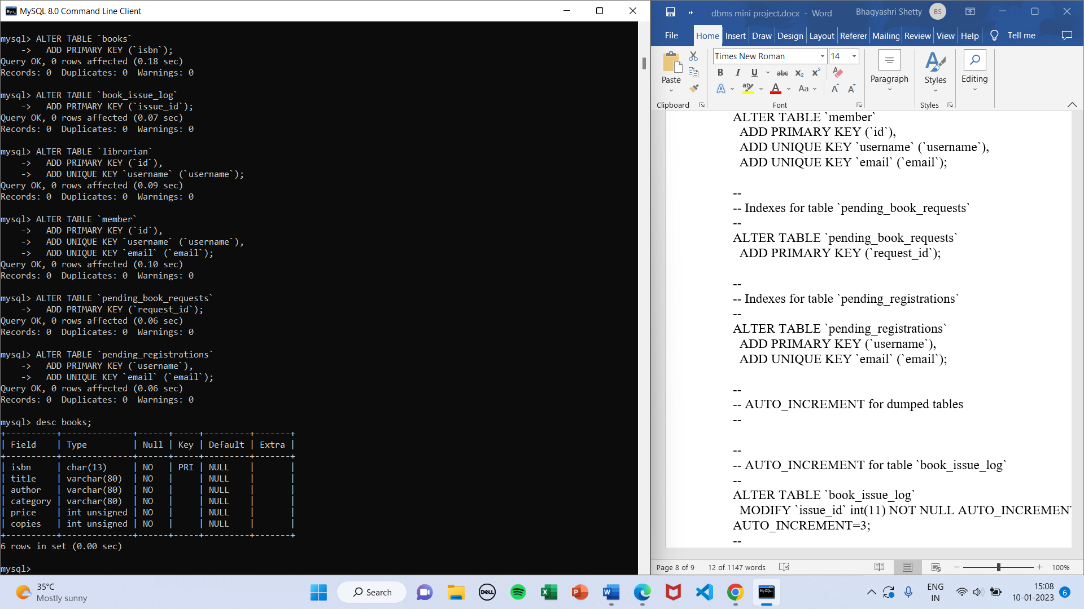

**AUTO_INCREMENT**:

AUTO_INCREMENT for dumped tables

AUTO_INCREMENT for table `book_issue_log`

ALTER TABLE `book_issue_log`

MODIFY `issue_id` int(11) NOT NULL AUTO_INCREMENT, AUTO_INCREMENT=3;

AUTO_INCREMENT for table `librarian`

ALTER TABLE `librarian`

MODIFY `id` int(11) NOT NULL AUTO_INCREMENT, AUTO_INCREMENT=2;

AUTO_INCREMENT for table `member`

ALTER TABLE `member`

MODIFY `id` int(11) NOT NULL AUTO_INCREMENT, AUTO_INCREMENT=4;

AUTO_INCREMENT for table `pending_book_requests`

ALTER TABLE `pending_book_requests`

MODIFY `request_id` int(11) NOT NULL AUTO_INCREMENT, AUTO_INCREMENT=6;

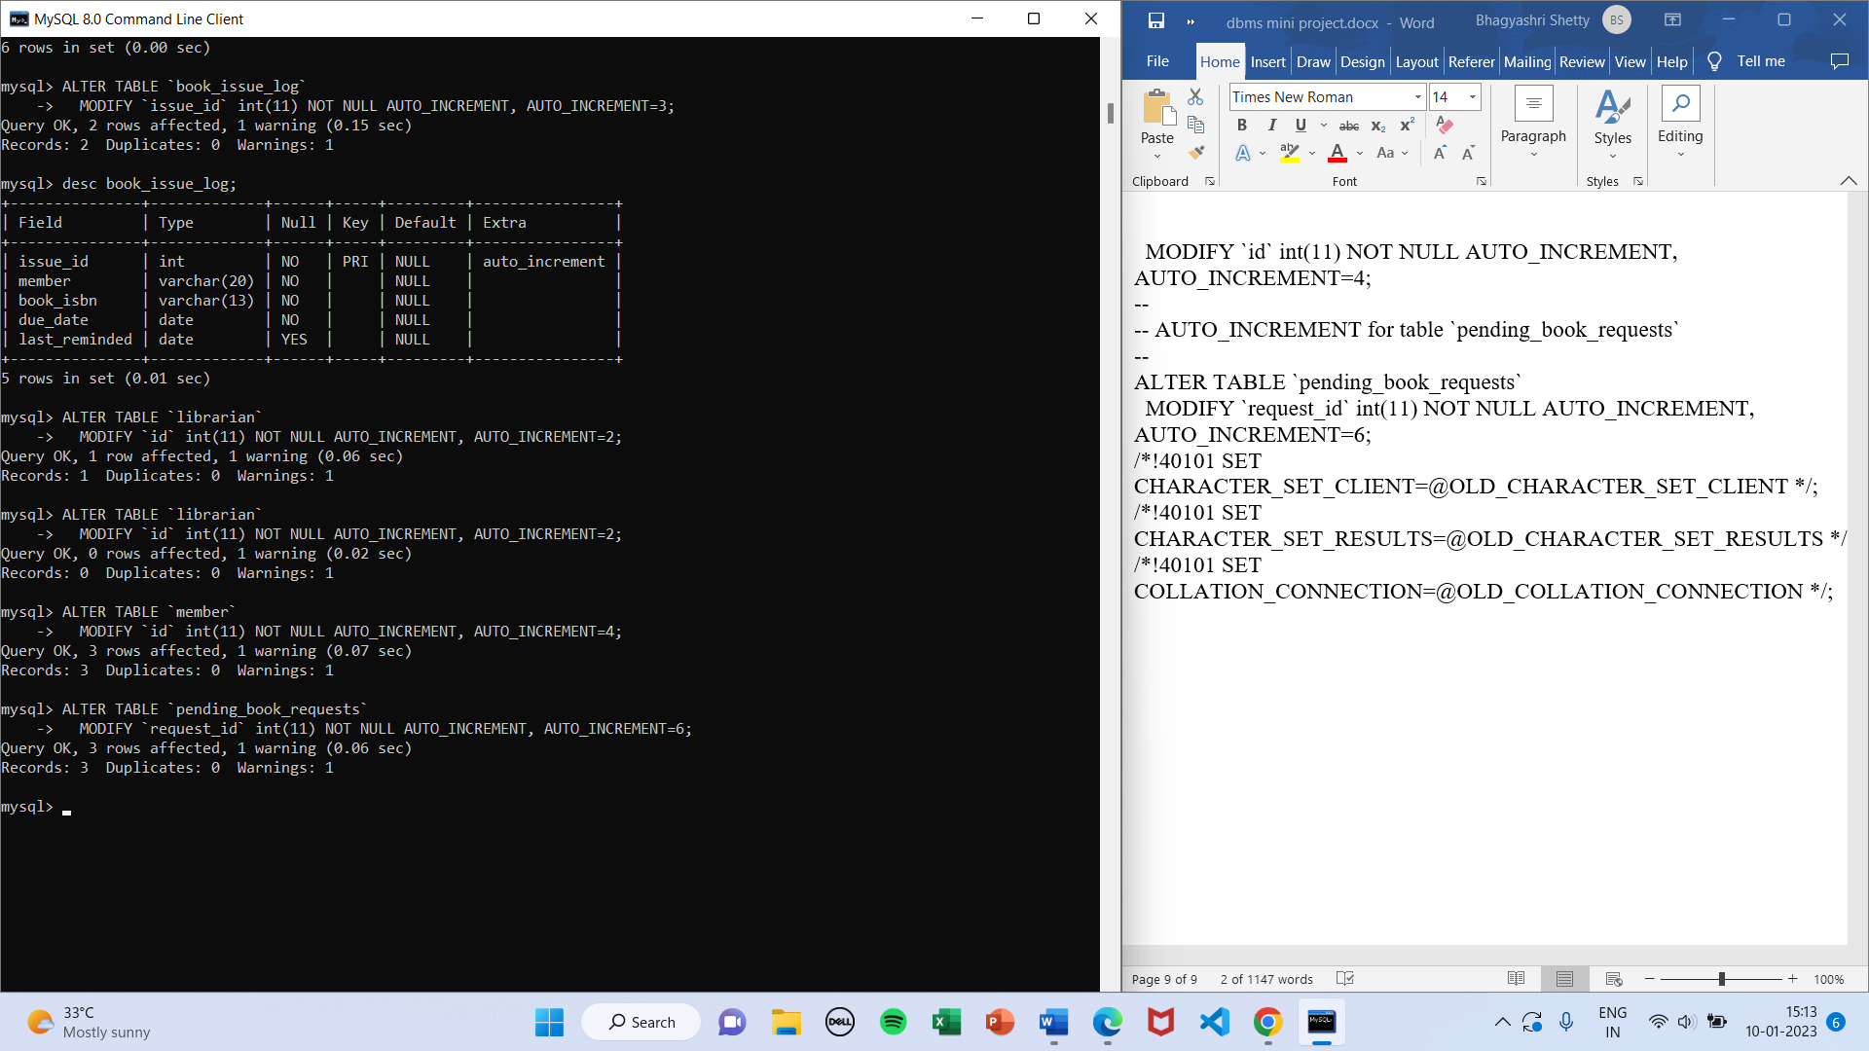

**TRIGGERS:**

**Triggers `book_issue_log` table**

* **Tigger issue book**

DELIMITER $$

CREATE TRIGGER `issue_book` BEFORE INSERT ON `book_issue_log` FOR EACH ROW BEGIN

SET NEW.due_date = DATE_ADD(CURRENT_DATE, INTERVAL 7 DAY);

UPDATE member SET balance = balance - (SELECT price FROM book WHERE isbn = NEW.book_isbn) WHERE username = NEW.member;

UPDATE book SET copies = copies - 1 WHERE isbn = NEW.book_isbn;

DELETE FROM pending_book_requests WHERE member = NEW.member AND book_isbn = NEW.book_isbn;

END

$$

DELIMITER ;

* **Trigger return book**

DELIMITER $$

CREATE TRIGGER `return_book` BEFORE DELETE ON `book_issue_log` FOR EACH ROW BEGIN

UPDATE member SET balance = balance + (SELECT price FROM book WHERE isbn = OLD.book_isbn) WHERE username = OLD.member;

UPDATE book SET copies = copies + 1 WHERE isbn = OLD.book_isbn;

END

$$

DELIMITER ;

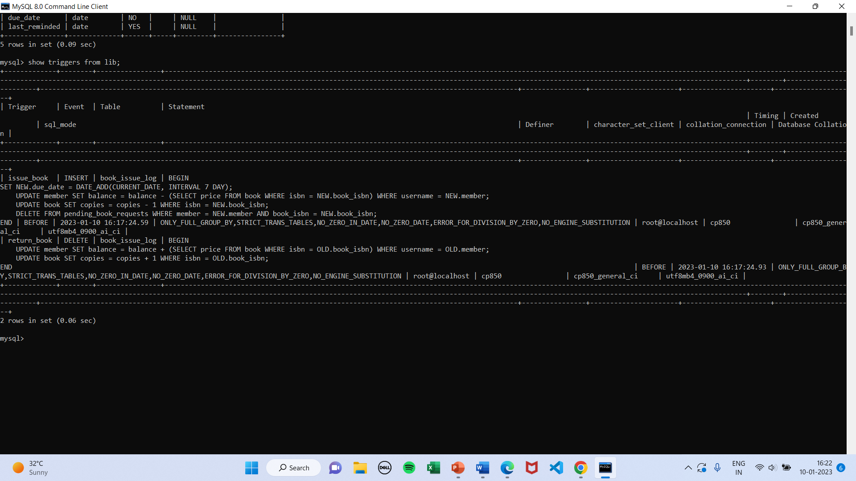

**Triggers `member`**

DELIMITER $$

CREATE TRIGGER `add_member` AFTER INSERT ON `member` FOR EACH ROW DELETE FROM pending_registrations WHERE username = NEW.username

$$

DELIMITER ;

DELIMITER $$

CREATE TRIGGER `remove_member` AFTER DELETE ON `member` FOR EACH ROW DELETE FROM pending_book_requests WHERE member = OLD.username

$$

DELIMITER ;

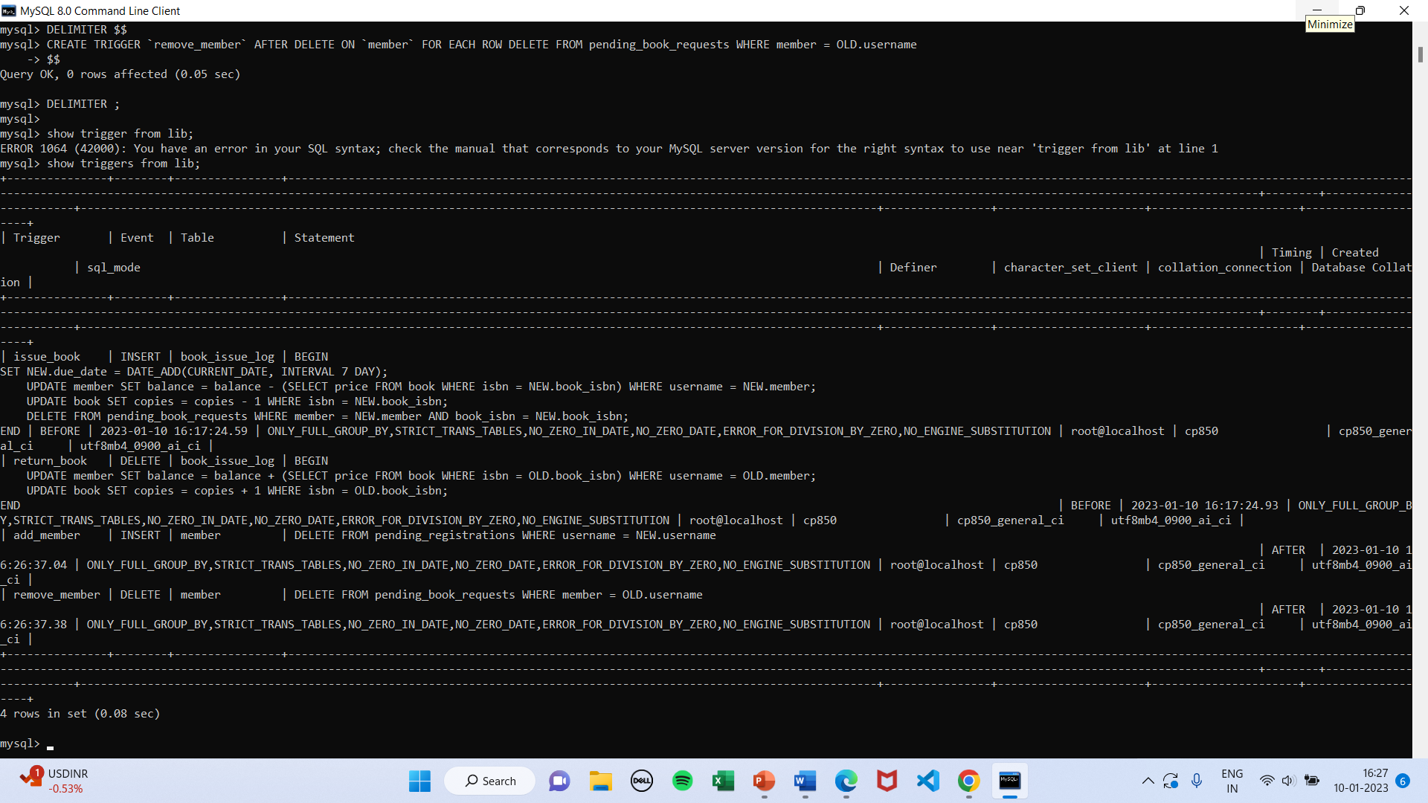

**Presented by: CSE 5A**

Babitha Rani B (1JS20CS040)

Bhagyashri Shetty H (1JS20CS043)